**Major – 2**

**1)Collect Fundamental Details**

from selenium import webdriver

from selenium.webdriver.common.by import By

from selenium.common.exceptions import NoSuchWindowException

import time

import json

# Set up the Chrome webdriver (you need to download chromedriver and specify its path)

driver = webdriver.Chrome()

def generate_stock_link(stock_logo):

base_url = 'https://www.screener.in/company/'

return base_url + stock_logo.upper() + '/consolidated'

def get_profit_and_loss_details(driver):

data = {}

# Find the profit and loss

profit_and_loss = driver.find_element(By.ID, 'profit-loss')

# Find the tables inside the section

tables = profit_and_loss.find_elements(By.CLASS_NAME, 'ranges-table')

for table in tables:

# Extract the table title

table_title = table.find_element(By.TAG_NAME, 'th').text.strip()

# Initialize an empty dictionary to store data for this table

table_data = {}

# Find all rows in the table body

rows = table.find_elements(By.TAG_NAME, 'tr')

# Iterate over each row (skip the first row which contains the title)

for row in rows[1:]:

# Extract the cells in this row

cells = row.find_elements(By.TAG_NAME, 'td')

# Extract the time period (e.g., "10 Years") and the value (e.g., "66%")

time_period = cells[0].text.strip()

value = cells[1].text.strip()

# Store the value in the table data dictionary

table_data[time_period] = value

# Store the table data in the main data dictionary with the table title as key

data[table_title] = table_data

return data

def get_revenue_and_net_profit_details(driver, section_class):

# Find the section

section = driver.find_element(By.ID, section_class)

# Find the content div inside the section

content_div_section = section.find_element(By.CLASS_NAME, 'fill-card-width')

# Find the table inside the content div

table_section = content_div_section.find_element(By.CLASS_NAME, 'data-table')

# Find the table header (thead) element

thead = table_section.find_element(By.TAG_NAME, 'thead')

# Find all th elements within the thead

th_elements = thead.find_elements(By.TAG_NAME, 'th')

# Initialize an empty array to store the table header content

table_header = []

# Iterate through each th element and extract its text content

for th in th_elements[1:]:

table_header.append(th.text.strip())

# Find the table body (tbody) element

tbody = table_section.find_element(By.TAG_NAME, 'tbody')

# Find stripe rows

tr_stripe_elements = tbody.find_elements(By.CLASS_NAME, 'stripe')

tr_strong_elements = tbody.find_elements(By.CLASS_NAME, 'strong')

# Initialize an empty array to store the Revenue data

Revenue = []

Net_Profit = []

# Iterate through stripe rows to find Revenue

for tr_stripe in tr_stripe_elements:

td_elements = tr_stripe.find_elements(By.TAG_NAME, 'td')

td_head = td_elements[0]

if td_head.text.strip() == "Revenue":

for td in td_elements[1:]:

Revenue.append(td.text.strip())

# Iterate through strong rows to find Net Profit

for tr_strong in tr_strong_elements:

try:

button_element = tr_strong.find_element(By.TAG_NAME, 'button')

if "Net Profit" in button_element.text:

td_elements = tr_strong.find_elements(By.TAG_NAME, 'td')

for td in td_elements[1:]:

Net_Profit.append(td.text.strip())

except NoSuchElementException:

pass

return {"Headers" : table_header, "Revenue" : Revenue, "Net Profit" : Net_Profit}

stock_logos = ["HDFCBANK", "ICICIBANK", "KOTAKBANK", "SBIN", "BAJFINANCE", "ITC", "HINDUNILVR", "TATAMOTORS", "BAJAJ-AUTO",

"MARUTI", "MRF", "INFY", "TCS", "WIPRO", "SUNPHARMA", "CIPLA", "RELIANCE", "LT", "ASIANPAINT", "TITAN"]

data = {}

for stock_logo in stock_logos:

stock_link = generate_stock_link(stock_logo)

# Delay for 2 seconds before navigating

time.sleep(2)

try:

# Navigate to the screener.com page for the specified stock

driver.get(stock_link)

except NoSuchWindowException as e:

print("Error: No window available. Make sure the browser window is open.")

time.sleep(5)

data[stock_logo] = {

"Quarters": get_revenue_and_net_profit_details(driver, "quarters"),

"Annual": get_revenue_and_net_profit_details(driver, "profit-loss"),

"ProfitAndLoss": get_profit_and_loss_details(driver)

}

# Save the data to a JSON file

with open('stock_data.json', 'w') as json_file:

json.dump(data, json_file)

print("Data saved to 'stock_data.json'")

# Close the webdriver

driver.quit()

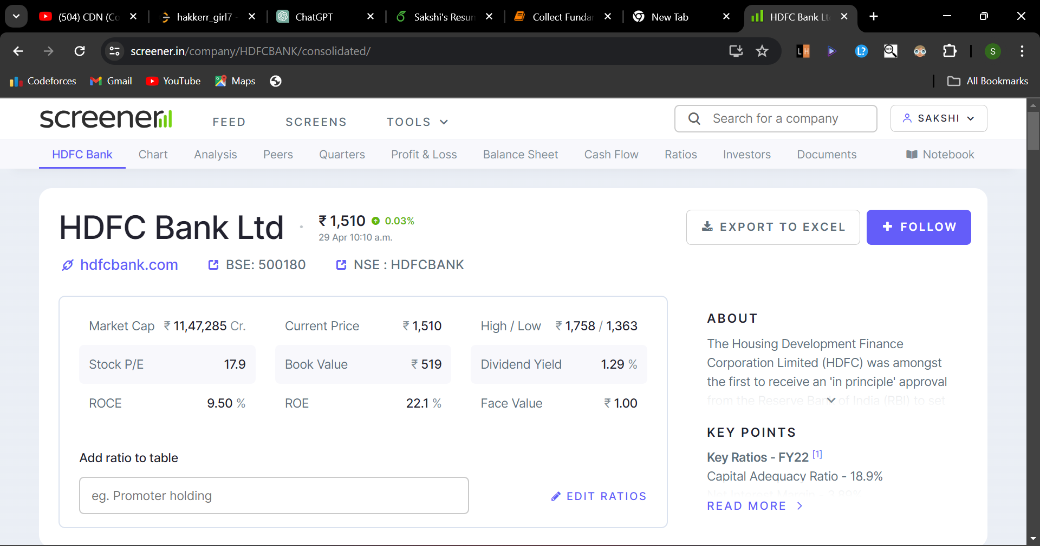

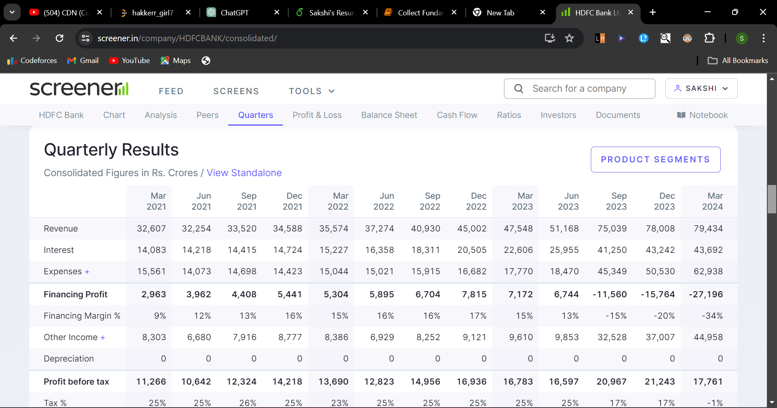

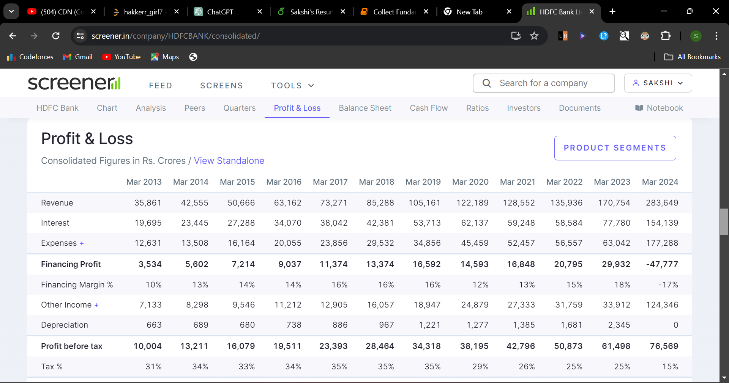

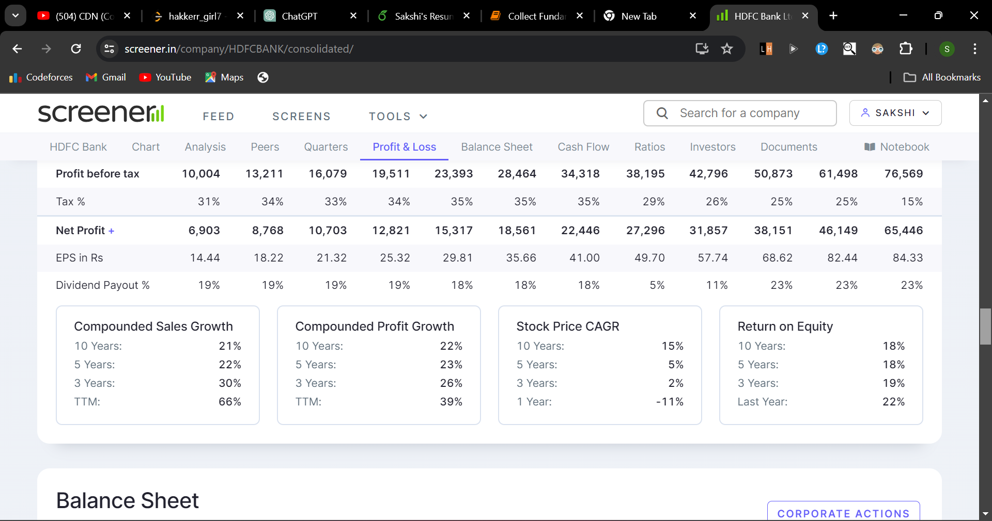



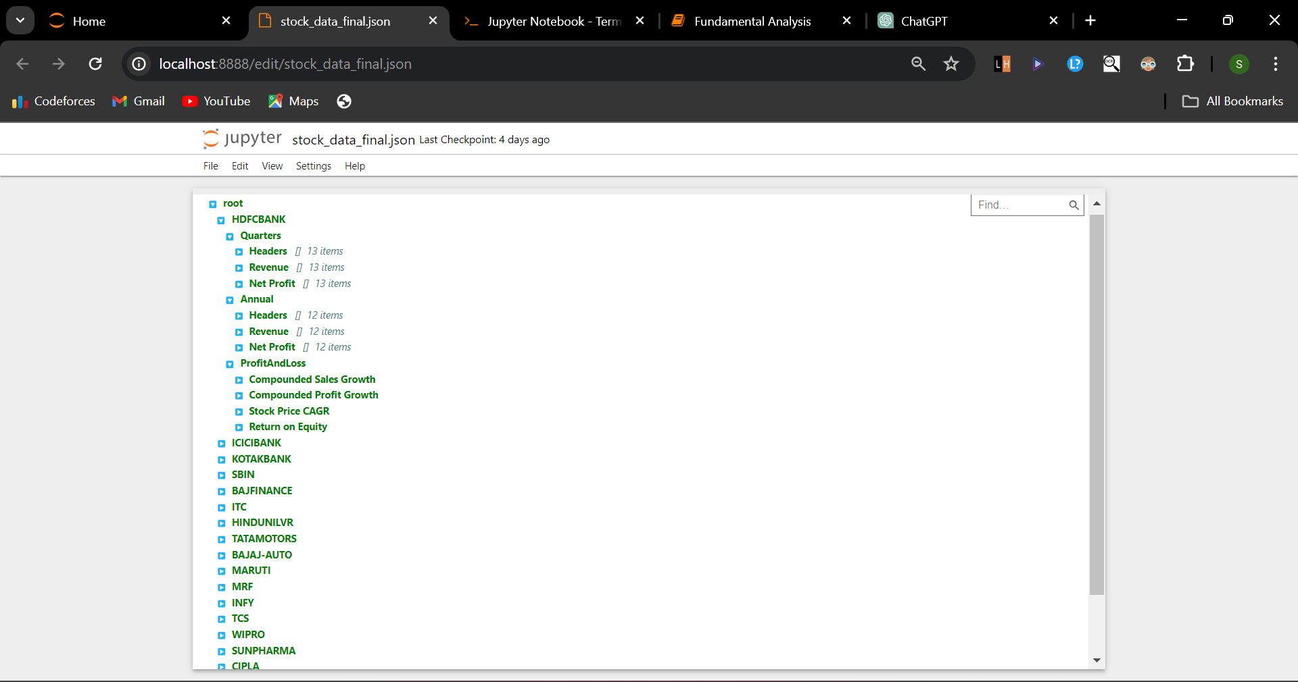

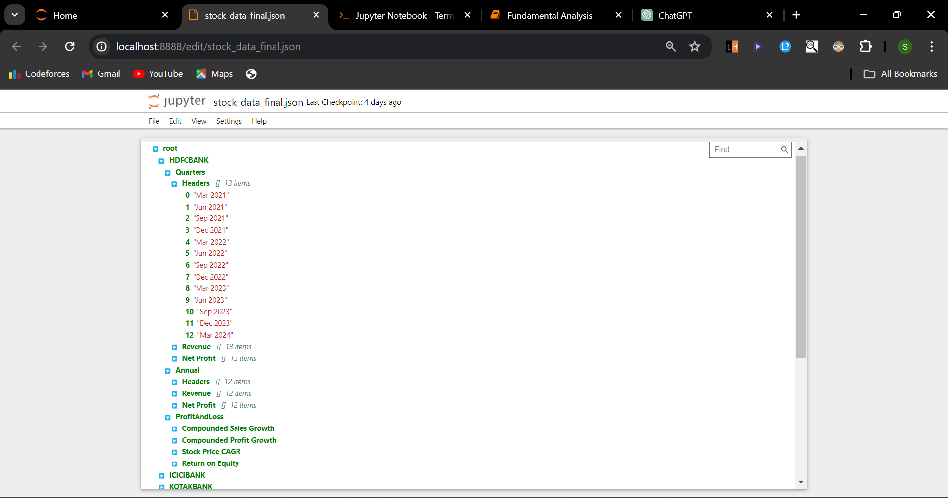

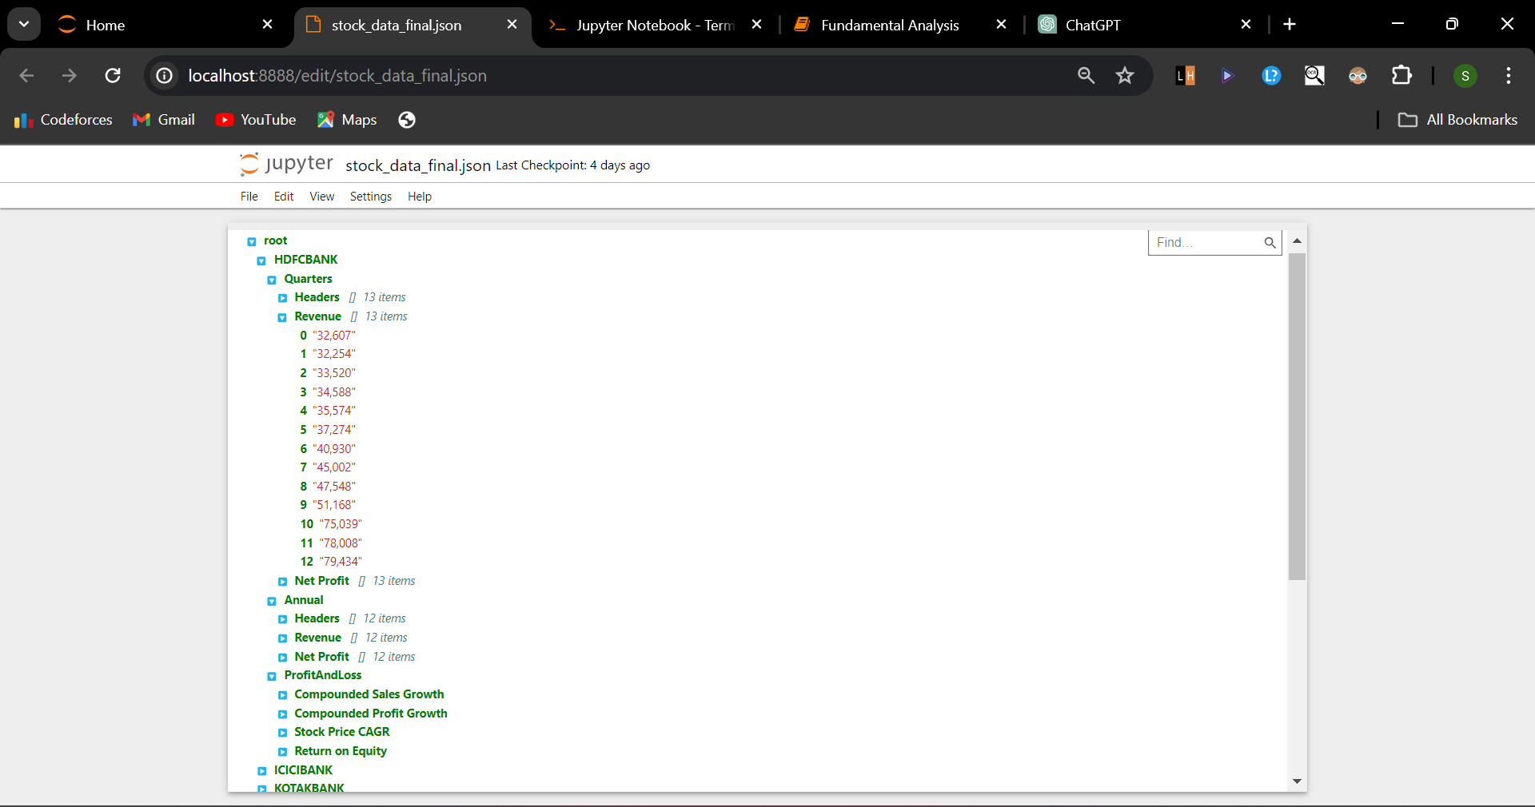

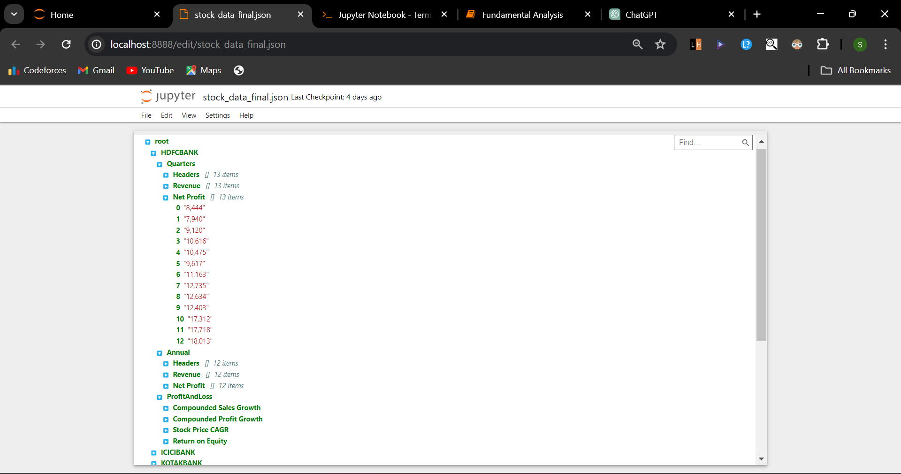

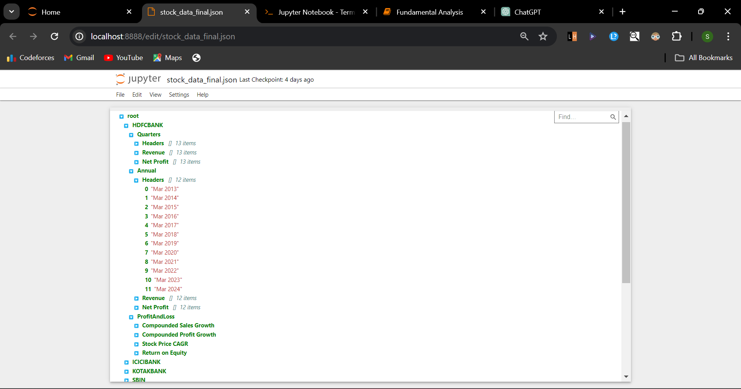

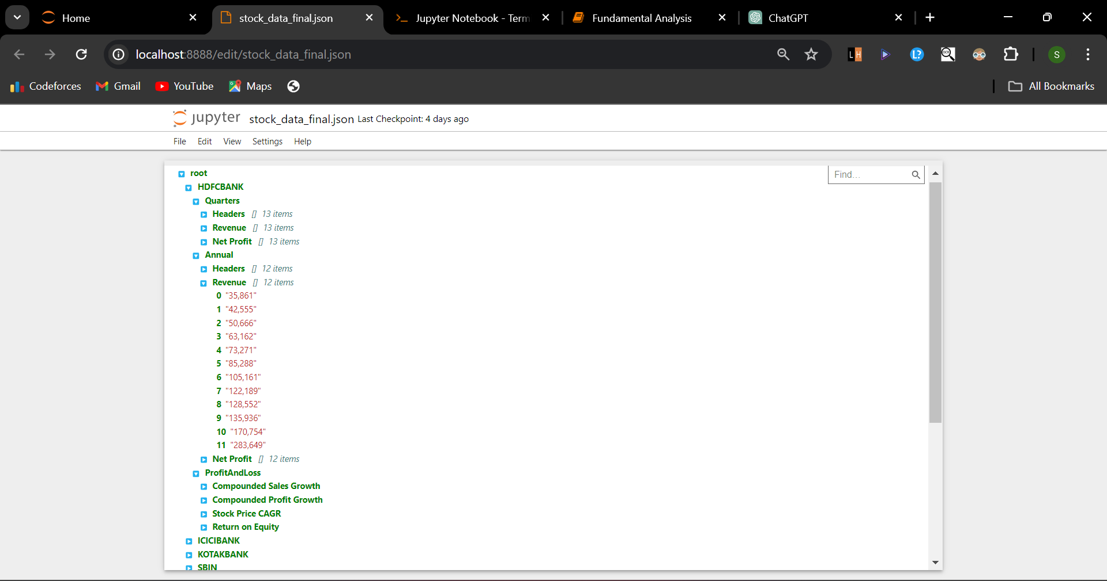

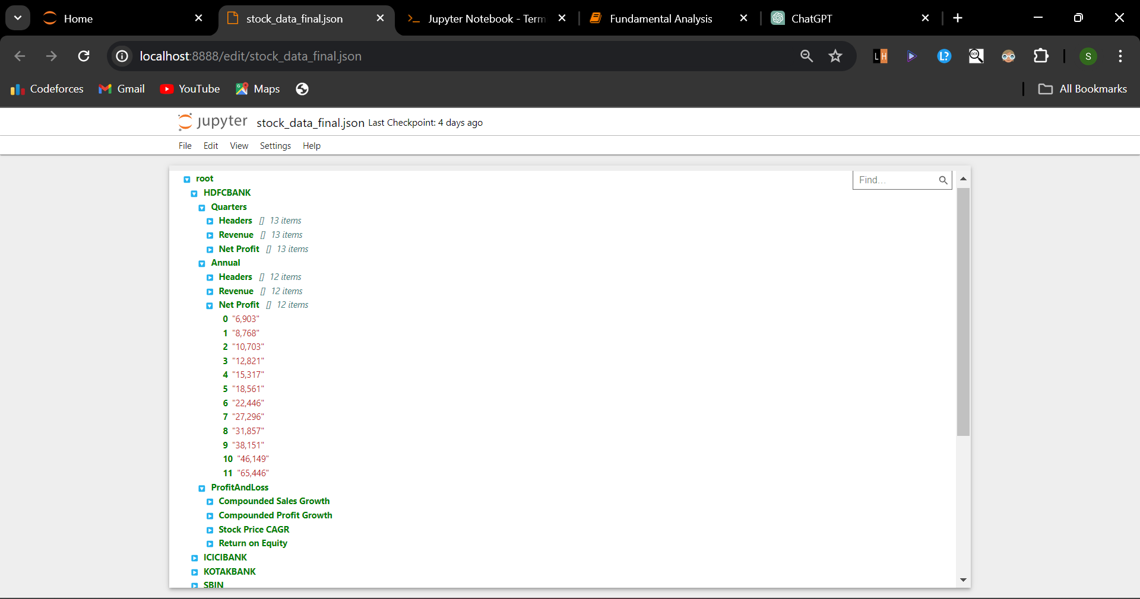

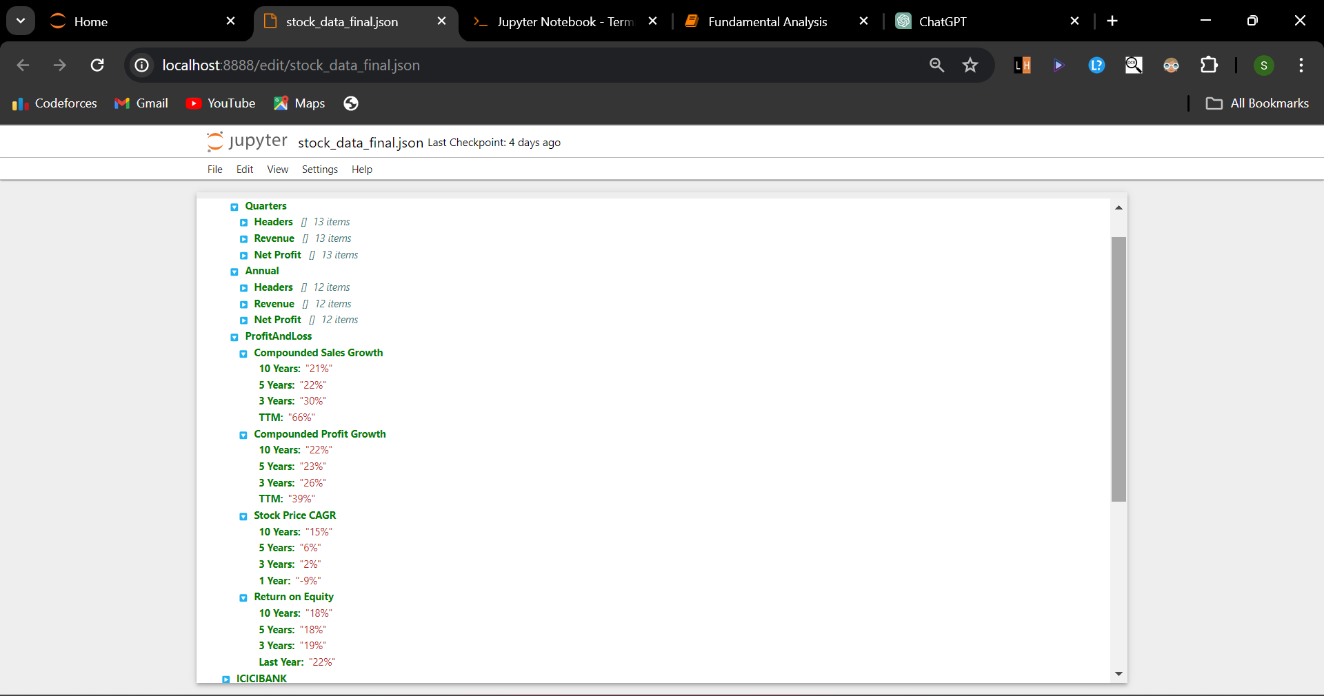

**2)Fundamental Analysis**

import json

import pandas as pd

import numpy as np

import matplotlib.pyplot as plt

from statsmodels.tsa.arima.model import ARIMA

from statsmodels.tsa.statespace.sarimax import SARIMAX

from sklearn.linear_model import LinearRegression

import warnings

import logging

warnings.filterwarnings('ignore')

logging.basicConfig(level=logging.ERROR)

# Load your JSON data

filename = 'stock_data_final.json'

with open(filename, 'r') as f:

data = json.load(f)

def forecast(stock, time_period):

# Extract the revenue data for quarters and annual

timeline = data[stock][time_period]['Headers']

revenue = data[stock][time_period]['Revenue']

net_profit = data[stock][time_period]['Net Profit']

# Parse the string data to integers

revenue = [int(rev.replace(',', '')) for rev in revenue]

net_profit = [int(rev.replace(',', '')) for rev in net_profit]

n = 4 # number of future points to predict

forecast_timeline = [timeline[-1]]

for i in range(n):

prev_time = timeline[-1 - 3 + i]

month, year = prev_time.split(' ')

upcoming_year = int(year) + 1 if time_period == 'Quarters' else int(year) + 4

next_time = ' '.join([month, str(upcoming_year)])

forecast_timeline.append(next_time)

# Forecasting for Revenue

model = ARIMA(revenue, order=(1,1,1))

model_fit = model.fit()

forecast = model_fit.get_forecast(steps=n)

print(f"Forecasted {time_period} Revenue for {stock}: ", forecast.predicted_mean)

# Plot original data

plt.figure(figsize=(15, 5))

plt.plot(timeline, revenue, color='blue', label='Original data')

# Insert last original value to forcasted data

forecasted_values = [revenue[-1]]

forecasted_values.extend(forecast.predicted_mean)

# Plot forecasted data with the last original point

plt.plot(forecast_timeline, forecasted_values, color='red', label='Forecasted data')

plt.title(f'{stock} - {time_period} Revenue Forecast')

plt.xlabel('Time')

plt.ylabel('Revenue')

plt.legend()

plt.show()

# Forecasting for Net Profit

model = ARIMA(net_profit, order=(1,1,1))

model_fit = model.fit()

forecast = model_fit.get_forecast(steps=n)

print(f"Forecasted {time_period} Net Profit for {stock}: ", forecast.predicted_mean)

# Plot original data

plt.figure(figsize=(15, 5))

plt.plot(timeline, net_profit, color='blue', label='Original data')

# Insert last original value to forcasted data

forecasted_values = [net_profit[-1]]

forecasted_values.extend(forecast.predicted_mean)

# Plot forecasted data with the last original point

plt.plot(forecast_timeline, forecasted_values, color='red', label='Forecasted data')

plt.title(f'{stock} - {time_period} Net Profit Forecast')

plt.xlabel('Time')

plt.ylabel('Net Profit')

plt.legend()

plt.show()

for stock in data.keys():

print(f"Processing data for {stock}")

try:

forecast(stock, 'Quarters')

forecast(stock, 'Annual')

except:

print(f"Could not process {stock} data completely")

break

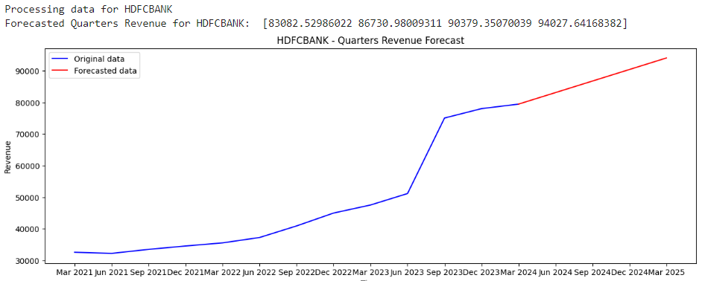

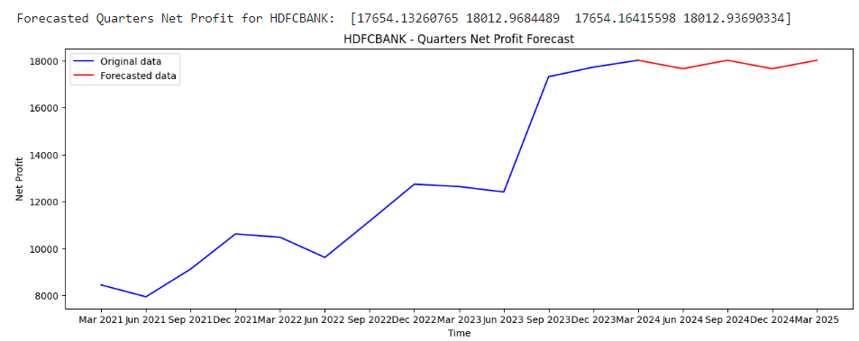

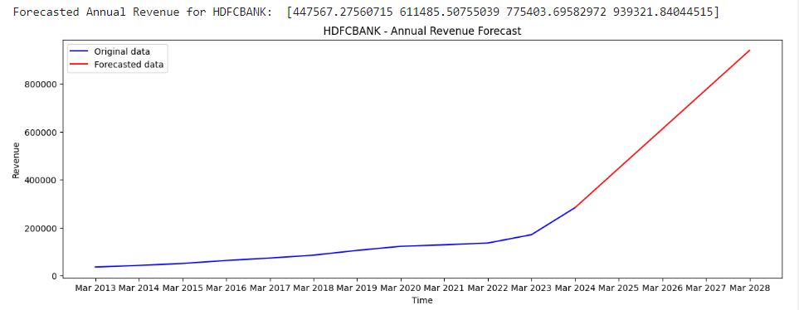

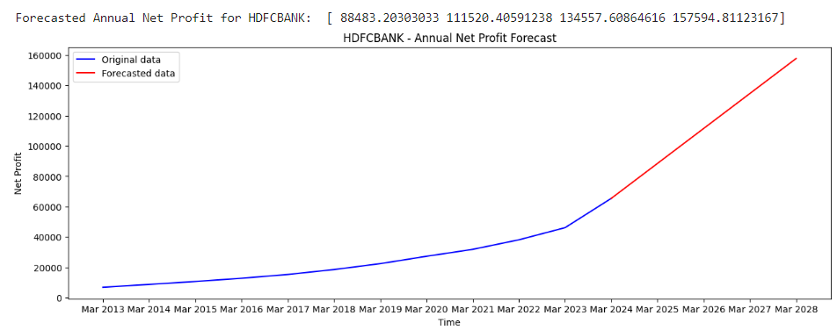

# Prepare the data

quarters_df = pd.DataFrame({

'ds': pd.to_datetime(data['HDFCBANK']['Quarters']['Headers']),

'y': [int(rev.replace(',', '')) for rev in data['HDFCBANK']['Quarters']['Revenue']]

})

# Specify the order of the model (p, d, q)(P, D, Q, m)

model = SARIMAX(quarters_df['y'], order=(1,1,1), seasonal_order=(1,1,1,4))

# Fit the model

model_fit = model.fit(disp=0)

# Make a future prediction

n = 3 # number of future points to predict

forecast = model_fit.get_forecast(steps=n)

# Create a time series for the forecasted data

forecasted_time = pd.date_range(start=quarters_df['ds'].iloc[-1], periods=n+1, freq='Q')[1:] # start from the next quarter

# Create a series for the forecasted values

forecasted_values = forecast.predicted_mean

# Append the last actual value and time to the forecasted values and time

last_actual_time = quarters_df['ds'].iloc[-1]

last_actual_value = quarters_df['y'].iloc[-1]

forecasted_time = pd.to_datetime([last_actual_time] + list(forecasted_time))

forecasted_values = np.concatenate(([last_actual_value], forecasted_values))

# Print the forecasted values

print('Forecasted Revenue: [', end = '')

for val in forecasted_values[:-1]:

print(int(val), end=', ')

print(f'{int(forecasted_values[-1])}]')

# Now, plot the graph again

plt.figure(figsize=(12, 5))

plt.plot(quarters_df['ds'], quarters_df['y'], label='Original data')

plt.plot(forecasted_time, forecasted_values, color='red', label='Forecasted data')

plt.legend()

plt.show()

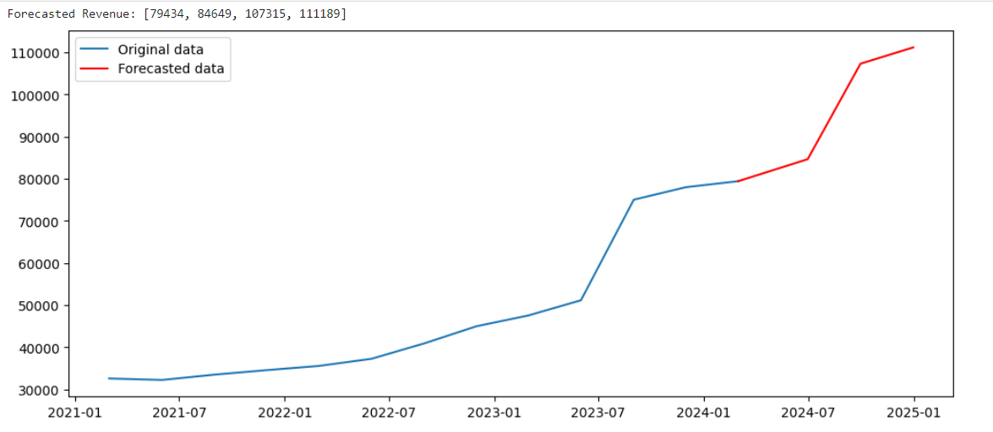

def forecast_revenue(revenues, n, k):

model = LinearRegression()

for _ in range(k):

X_train = np.array(range(len(revenues[-n:]))).reshape(-1,1)

y_train = np.array(revenues[-n:]).reshape(-1,1)

model.fit(X_train, y_train)

X_test = np.array(len(revenues)).reshape(-1,1)

forecasted_revenue = model.predict(X_test)

# Append the forecasted revenue to the original list

revenues.append(int(forecasted_revenue[0][0]))

return revenues

timeline = pd.to_datetime(data['HDFCBANK']['Quarters']['Headers'])

revenues = [int(rev.replace(',', '')) for rev in data['HDFCBANK']['Quarters']['Revenue']]

n = len(revenues)

k = 3

forecasted_revenues = forecast_revenue(revenues, n, k)

print(forecasted_revenues[n-1:])

# Extend timeline for forecasted quarters assuming each quarter is 3 months apart

forecast_timeline = pd.date_range(start=timeline[-1], periods=k+1, freq='Q')[1:]

timeline = timeline.append(forecast_timeline)

# Plotting

plt.figure(figsize=(12,5))

plt.plot(timeline[:n], revenues[:n], label='Actual')

plt.plot(timeline[n-1:], forecasted_revenues[n-1:], label='Forecasted') # n-1 to include the last actual point in forecast plot

plt.xlabel('Quarters')

plt.ylabel('Revenue')

plt.title('Revenue Forecast')

plt.legend()

plt.show()

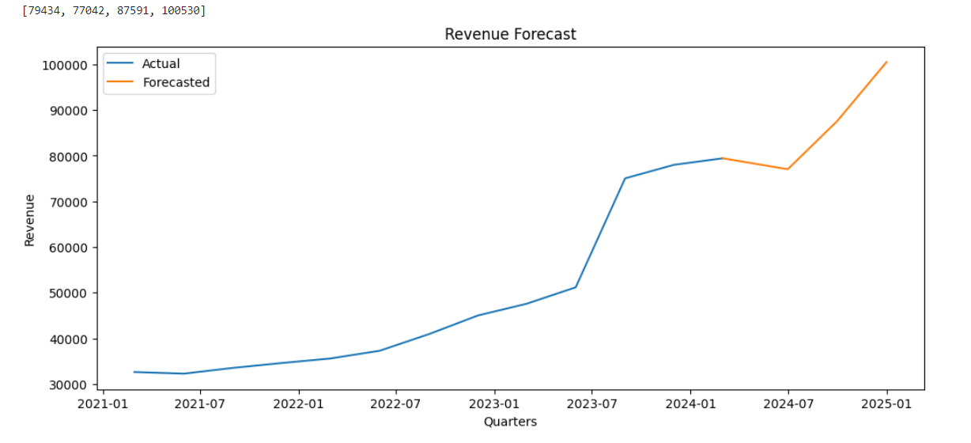

**3. Technical Analysis through RNN**

import numpy as np

import pandas as pd

from keras.models import Sequential

from keras.layers import LSTM, Dense, Dropout

from sklearn.preprocessing import MinMaxScaler

import matplotlib.pyplot as plt

from sklearn.metrics import mean_absolute_error, mean_squared_error, r2_score

import math

import warnings

import logging

warnings.filterwarnings('ignore')

logging.basicConfig(level=logging.ERROR)

data = pd.read_csv('Datasets/SCRIP/SBIN.csv')

data['Date'] = pd.to_datetime(data['Date'])

startDate = '2018-01-01'

endDate = '2020-01-01'

data = data[(data['Date'] >= startDate) & (data['Date'] <= endDate)]

data['Date'] = (data['Date'] - data['Date'].min()).dt.days

data = data.dropna()

scaler = MinMaxScaler(feature_range=(0,1))

scaled_data = scaler.fit_transform(data['Close'].values.reshape(-1,1))

def create_dataset(dataset, look_back=60):

X, Y = [], []

for i in range(look_back, len(dataset)):

X.append(dataset[i-look_back:i, 0])

Y.append(dataset[i, 0])

return np.array(X), np.array(Y)

X, Y = create_dataset(scaled_data)

train_size = int(len(X) * 0.7)

test_size = len(X) - train_size

X_train, X_test = X[0:train_size,:], X[train_size:len(X),:]

Y_train, Y_test = Y[0:train_size], Y[train_size:len(X)]

X_train = np.reshape(X_train, (X_train.shape[0], X_train.shape[1], 1))

X_test = np.reshape(X_test, (X_test.shape[0], X_test.shape[1], 1))

model = Sequential()

model.add(LSTM(units=50, return_sequences=True, input_shape=(X_train.shape[1],1)))

model.add(Dropout(0.2))

model.add(LSTM(units=50, return_sequences=False))

model.add(Dropout(0.2))

model.add(Dense(units=25))

model.add(Dense(units=1))

model.compile(optimizer='adam', loss='mean_squared_error')

model.fit(X_train, Y_train, epochs=20, batch_size=32)

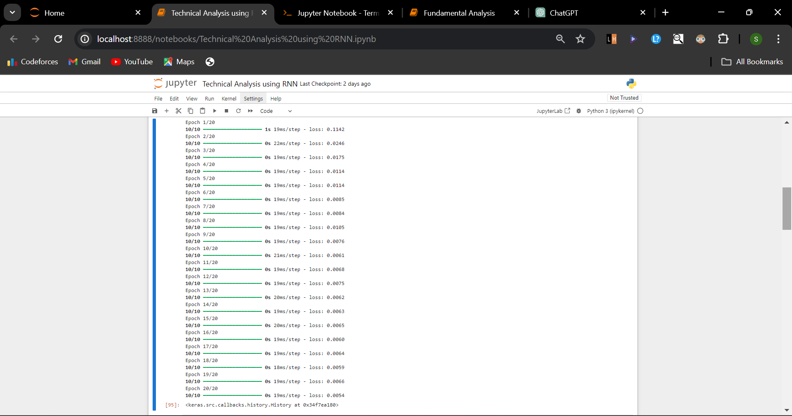

# Calculate the Mean Absolute Error

k = train_size

mae = mean_absolute_error(overall_actual[k:], overall_predicted[k:])

print('Mean Absolute Error:', mae)

# Calculate the Mean Squared Error

mse = mean_squared_error(overall_actual[k:], overall_predicted[k:])

print('Mean Squared Error:', mse)

# Calculate the Root Mean Squared Error

rmse = math.sqrt(mean_squared_error(overall_actual[k:], overall_predicted[k:]))

print('Root Mean Squared Error:', rmse)

# Calculate the R2 score

r2 = r2_score(overall_actual[k:], overall_predicted[k:])

print(f'R2 score: {r2}')

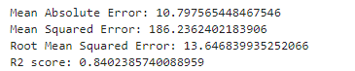

plt.figure(figsize=(16,8))

plt.title('Model')

plt.xlabel('Date', fontsize=18)

plt.ylabel('Close Price', fontsize=18)

plt.plot(actual)

plt.plot(predictions)

plt.legend(['Actual', 'Predictions'], loc='lower right')

plt.show()

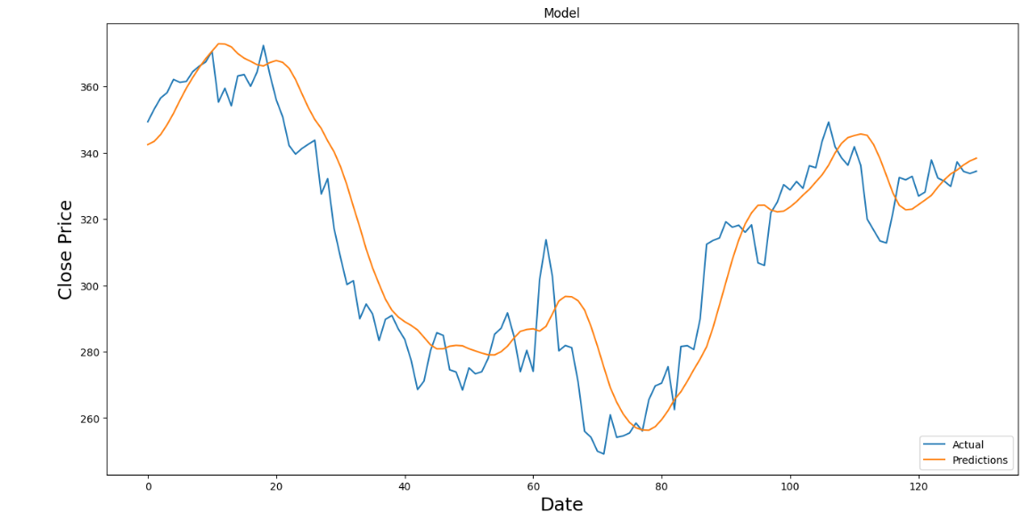

plt.figure(figsize=(16,8))

plt.title('Model')

plt.xlabel('Date', fontsize=18)

plt.ylabel('Close Price', fontsize=18)

plt.plot(overall_actual)

plt.plot(overall_predicted)

plt.legend(['Actual', 'Predictions'], loc='lower right')

plt.show()

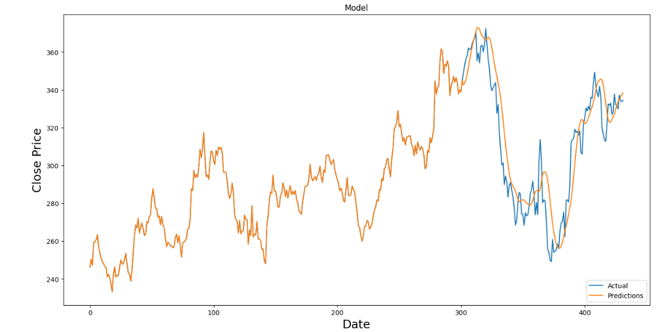

**4. Support and Resistance through K Means**

import math

import random

import numpy as np

import pandas as pd

import matplotlib.pyplot as plt

import matplotlib.colors as mcolors

# Here cost function is simply the Manhattan distance (absolute diff) between the 2 points

def cost(p1, p2):

return np.abs(p1 - p2)

# Calculating total cost by summing up the costs in each cluster

def calculateTotalCost(clusters, means):

totalCost = 0

for i in range(len(clusters)):

for point in clusters[i]:

totalCost += cost(means[i], point) **2

return totalCost ** 0.5

def kMeans(data, k, showClusters = False, maxIterations = 100, markerSize = 1):

n = len(data)

minVal, maxVal = np.min(data), np.max(data)

assignedClusterIds = np.zeros(n, dtype=int)

bestClusters = []

bestMeans = []

bestAssignedClusterIds = []

minTotalCost = n * (maxVal - minVal) # This is the maximum possible cost (assume mean is at minVal & all the n points at maxVal)

# This outermost loop would really be useful when we randomize means instead of uniformly distributing

# So by default it will run only once

for iteration in range(maxIterations):

clusters = []

# Initialize means

means = [np.random.choice(data) for _ in range(k)]

# Repeat the process of readjusting means 20 times

maxCycles = 50

# Cluster data by minimizing cost

for cycle in range(maxCycles):

clusters = [[] for _ in range(k)]

for index, value in enumerate(data):

# Max diff between any 2 points

minCost = maxVal - minVal

minClusterId = 0

# Calculate the distance of the point from each mean

for i in range(k):

curCost = cost(means[i], value)

# Choose the cluster with closest mean

if (curCost < minCost):

minCost = curCost

minClusterId = i

# Assign the point to the cluster with the nearest mean value

clusters[minClusterId].append(value)

assignedClusterIds[index] = minClusterId

# Readjust mean values

for i in range(k):

numElements = len(clusters[i])

if numElements > 0:

means[i] = sum(clusters[i]) / numElements

else:

means[i] = np.random.choice(data)

# Find total cost for current clustering

totalCost = calculateTotalCost(clusters, means)

# Choose the overall best clustering

if (totalCost < minTotalCost):

minTotalCost = totalCost

bestClusters = clusters

bestMeans = means

bestAssignedClusterIds = assignedClusterIds

if (showClusters):

showClustering(range(n), data, assignedClusterIds, means, markerSize)

return bestClusters, bestMeans, bestAssignedClusterIds

# Plot data by color coding each cluster differently

def showClustering(x, y, assignedClusterIds, SNR, markerSize = 1):

numColors = 10

HSV_tuples = [(i/numColors, 1.0, 1.0) for i in range(numColors)]

RGB_tuples = list(map(lambda x: mcolors.hsv_to_rgb(x), HSV_tuples))

plt.figure(figsize=(10,6))

for i in range(len(x)):

plt.scatter(x[i], y[i], color = RGB_tuples[assignedClusterIds[i] % numColors], s = markerSize)

# Plot horizontal lines at the support & resistances

for snrValue in SNR:

plt.axhline(y=snrValue, color='black', linestyle='--')

plt.annotate(f'{snrValue}', xy=(1, snrValue), xycoords=('axes fraction', 'data'), textcoords='offset points', xytext=(5, 0), ha='left', va='center', color='black')

plt.show()

points = np.array([1,2,4,5,22,24,26,28,50,60,30,20])

k = 3

clusters, means, assignedClusterIds = kMeans(points, k, True, 10, 50)

print(f'Clusters: {clusters}')

print(f'Means: {means}')

print(f'Assigned Cluster Ids: {assignedClusterIds}')

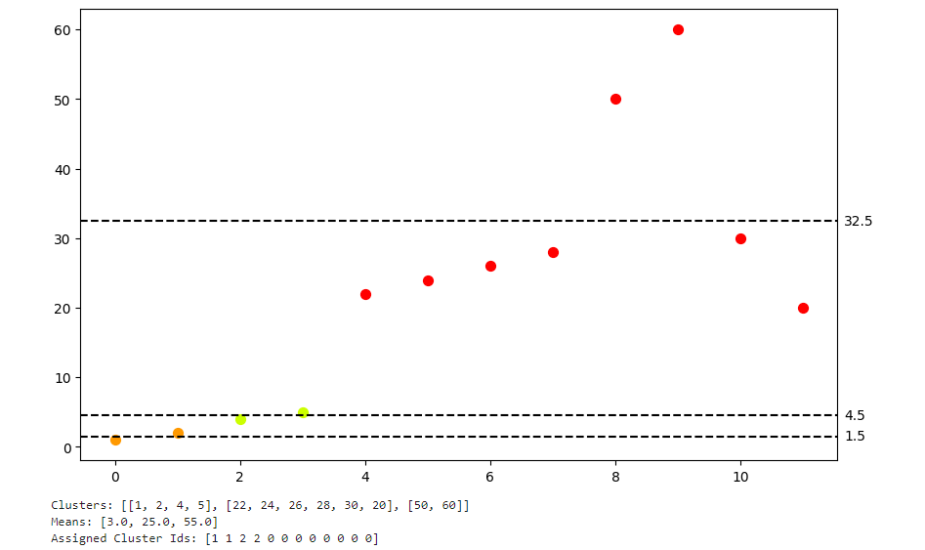

def autoKMeans(data, maxClusters = 10, showElbowCurve = False, showBestClustering = False):

totalCosts = [float('inf')] # for 0 clusters, cost is infinity

for k in range(1, min(len(data), maxClusters) + 1):

clusters, means, _assignedClusterIds = kMeans(data, k)

totalCosts.append(calculateTotalCost(clusters, means))

# Find the elbow point - value of k for most optimal clustering (highest reduction in cost on increasing total clusters by 1)

bestK = 1

maxAngleDiff = 0

for k in range(2, len(totalCosts) - 1):

x1, y1 = 10 * (k - 1), totalCosts[k - 1]

x2, y2 = 10 * k, totalCosts[k]

x3, y3 = 10 * (k + 1), totalCosts[k + 1]

prevAngle = math.degrees(math.atan(abs((y2 - y1) / (x2 - x1))))

curAngle = math.degrees(math.atan(abs((y3 - y2) / (x3 - x2))))

angleDiff = prevAngle - curAngle

# print(prevAngle, curAngle, angleDiff)

if (angleDiff > maxAngleDiff):

maxAngleDiff = angleDiff

bestK = k

# Plotting the totalCosts for each k

if (showElbowCurve):

plt.figure(figsize=(10,6))

plt.plot(range(1, len(totalCosts)), totalCosts[1:], marker='o')

plt.plot(bestK, totalCosts[bestK], marker='o', color='orange')

plt.annotate('Elbow point', (bestK, totalCosts[bestK]), textcoords="offset points", xytext=(40,10), ha='center')

plt.xlabel('Number of clusters (k)')

plt.ylabel('Total Cost')

plt.title('Total Cost vs Number of Clusters')

plt.grid(True)

plt.show()

return kMeans(data, bestK, showBestClustering)

autoKMeans(points, 10, True)

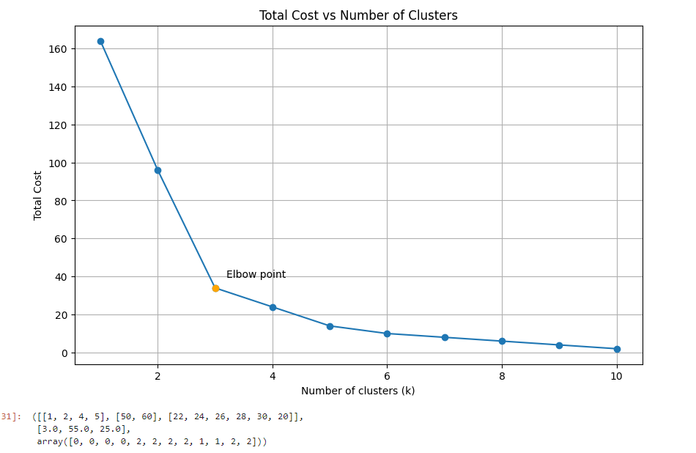

# Main

# Load the stock prices of ITC using pandas

dataframe = pd.read_csv('Datasets/SCRIP/ITC.csv')

# Select the relevant attributes and rename them

data = dataframe[['Date', 'Close']].rename(columns = {'Close': 'Price'})

# Convert the price from string to float convert coerce mode converts non-numeric strings to NaN

data['Price'] = pd.to_numeric(data['Price'], errors = 'coerce')

# Convert dates to datetime format

data['Date'] = pd.to_datetime(data['Date'])

# Slice the time range

startDate = '2007-01-01'

endDate = '2024-01-01'

data = data[(data['Date'] >= startDate) & (data['Date'] <= endDate)]

# Subtract the initial date from all dates and convert it into days (we only need these indexes to plot)

data['Date'] = (data['Date'] - data['Date'].min()).dt.days

# Drop rows that have NaN values

data = data.dropna()

# Convert single columns into numpy arrays

prices = data['Price'].values

dates = data['Date'].values

print(max(prices))

print(len(prices))

print(prices)

print(dates[0:12]) # Notice that Saturday-Sunday markets are closed

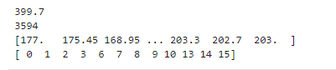

# This is an expensive process. Will take some time depending on your machine.

clusters, means, assignedClusterIds = autoKMeans(prices)

# Calculating all the Support & Resistance lines (SNR)

supports = []

resistances = []

for cluster in clusters:

supports.append(math.floor(min(cluster)))

resistances.append(math.floor(max(cluster)))

supports.sort()

resistances.sort()

SNR = [supports[0]] # bottom line

# Middle lines

for i in range(len(clusters) - 1):

SNR.append((resistances[i] + supports[i + 1]) / 2)

SNR.append(resistances[len(clusters) - 1]) # top line

showClustering(dates, prices, assignedClusterIds, SNR)

